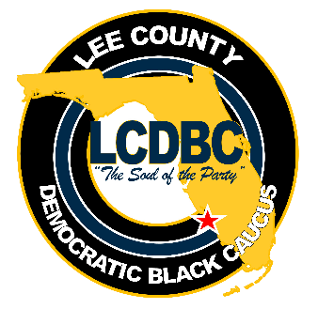

LEE COUNTY DEMOCRATIC BLACK CAUCUS
General Membership Meeting via Zoom

Janice Cass, President

February 16, 20201 – 6:30 P.M.

AGENDA

- Call to Order/Prayer/Pledge of Allegiance

- Declaration of Quorum/Agenda Approval

- President’s welcome and recognition of Elected Officials

- Treasurer’s Report

- Minutes

- President’s Report & Committee Reports

- Action Items
- Slate of Nominees & Election Process
- Wells Fargo Bank Account Changes
- Vote on Designating a Deputy Treasurer (Interim Position)

- Unfinished Business
- Membership Renewals

- New Business
- Public Housing Authority – Residents Council & Voter Education

- For Our Information/Good of the Order

- Adjournment (on or about 8:00 p.m.)

