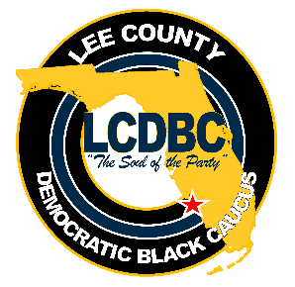

LEE COUNTY DEMOCRATIC BLACK CAUCUS
MEETING MINUTES

January 19, 2021 - 6:30 P.M.

ZOOM CONFERENCE

Members Present: Janice Cass, Nancy Simms, Shawn Williams, Ron Treaseh, Robert Norris, Elizabeth Williams, Willie Middleton, Ruby Hendley, Carolyn Moore, and Carolyn Norris

Visitors: Jim Rosinus, Tim Dues, Crystal Czyscon, and Malcom Godwin

The meeting was called to order at 6:40 p.m., followed by prayer and pledge of allegiance.

Roll call conducted and quorum was declared.

The agenda was reviewed and approved as presented. Motion was made by Robert Norris and seconded by Ron Treaseh. Motion carried.

Treasurer’s Report was reviewed. There was no update available regarding the Wild Apricot deposit of $25.00 from prior month. Report accepted as filed, subject to audit.

Minutes from October 20, 2020 meeting was reviewed. Motion to accept was made by Shawn Williams and seconded by Robert Norris. Motion passed.

Action Items

None

President’s Report

President Cass issued her report where she cited statistics for early voting, same day voting and outcomes of the November 3rd General Election.

Next, President Cass opened the meeting in a “round table” format to discuss the recent election.

Most of the members and visitors expressed they were happy with the Biden-Harris win for presidency; however, there were mixed feelings about the local elections, although most agreed that some in-roads were made. We all acknowledged the efforts made by our Caucus member, Shawn Williams, for his respectable and valiant campaign for State House 78.
Some of the sentiments expressed were: (1) the results of the presidential race tells where this country stands since Biden won with 78 million voters, but Trump remarkably received 70 million votes; (2) the local races showed Democrats making some in-roads, but the Republicans showed a significant increase in turnout, same day and voting by mail; (3) there are still concerns about voting by mail and voting down ballot for Democrats; (4) some were content with the outcome of certain amendments, i.e., open primaries did not pass, and the minimum wage increase had passed; (5) the newly restored early voting status was restored to Carrie Robinson Center, which out-performed the Riverside Community Center location; (6) one member’s phone banking experience confirmed very low participation from younger people, 35 years and younger. There is a need for better outreach to this demographic; and (7) several members concurred that having a more visible and permanent presence (an office) in Dunbar is needed, in addition to endorsing Democratic candidates earlier, especially when they do not have opponents.

Unfinished Business

- Nominating Committee to be formed. Janice encouraged all members to renew their memberships timely. All dues must be paid by before February 28, 2021 to participate in the March 16, 2021 election of officers.

- Bylaws Revisions - tabled

New Business

- Look at developing voter education workshops (possible location, The Q) to reach and prepare the youth.
- Establish - Committee for Office Space for LCDBC. Members are Shawn Williams, Elizabeth Williams, Robert Norris, and Ron Treaseh since these members all touched on the need for a physical presence to reach the community in the round table discussion.

For Your Information/Good of the Order

Willie Middleton inquired about LCDBC’s need to approve the meeting agenda and its format; Janice explained the DBCF mandated this format at an Executive Committee Meeting held earlier in Jacksonville, FL.

Next meeting is scheduled for Tuesday, January 19, 2020 at 6:30 p.m. No December meeting will be held.

Having no other business, meeting adjourned at 8:17 p.m.

Respectfully submitted,

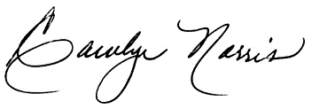

Carolyn Norris
Recording Secretary

